**Project Creation –**

Simple Maven Project; and then add Spring Dependencies at POM.xml to make it a Spring Implementation.

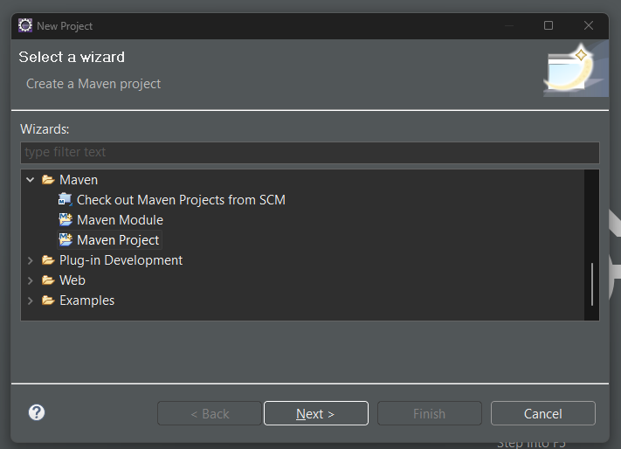

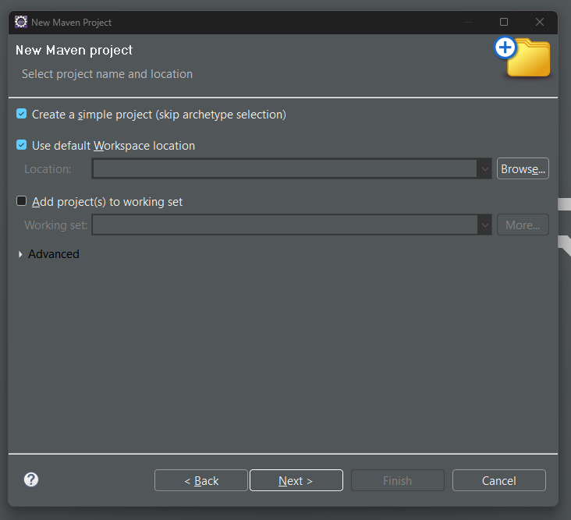

Spring MVC Setup

Add applications.proprties file at src/main/resources folder

Mention below attributes as view resolver:

spring.mvc.view.prefix: /WEB-INF/views/

spring.mvc.view.suffix: .jsp

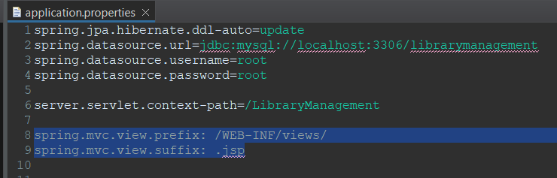

Building the code before execution:

Go to pom.xml 🡪 context menu 🡪 Run As 🡪 Maven Install

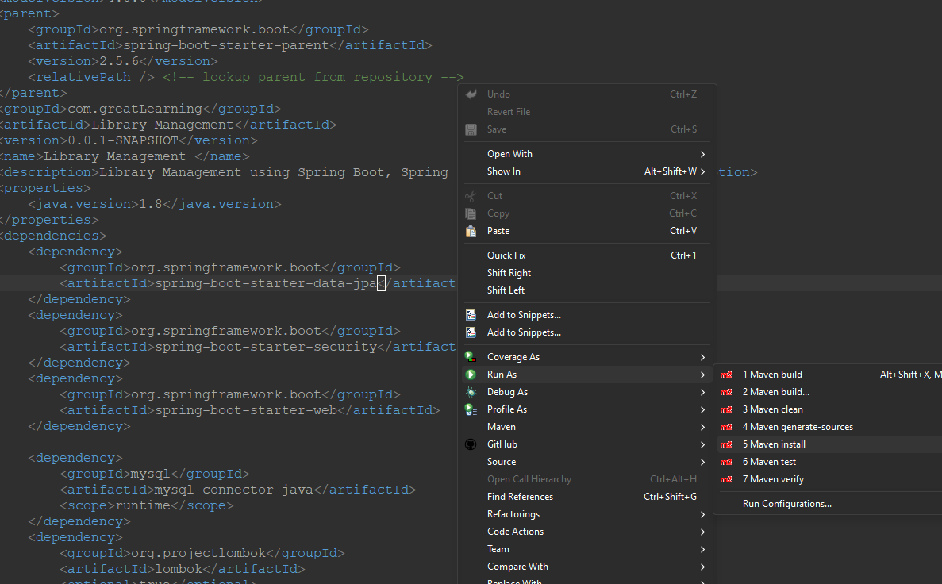

Wait till the project gets Build, and the success message

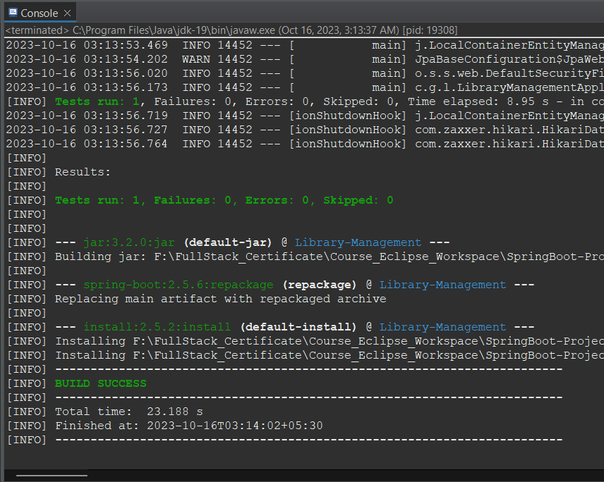

Database Setup:

1. Create the database

> create database librarymanagement

1. User Table

Way 1: Insert the Username password at database level using insert query.

Decrypt the password at <https://bcrypt-generator.com/> before inserting

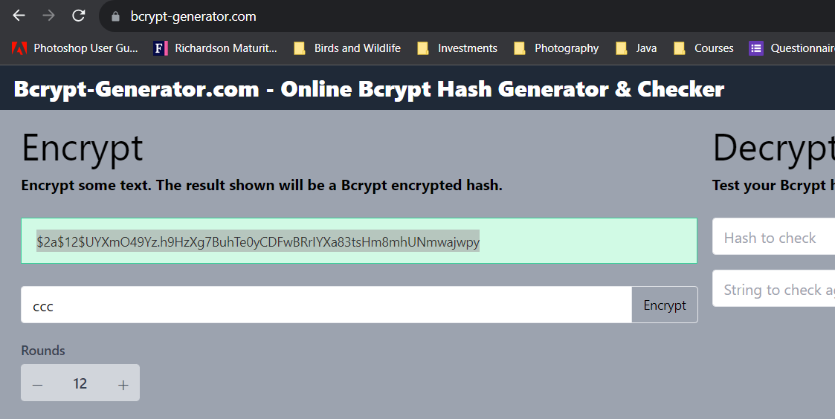

Table would look like this after Insert queries

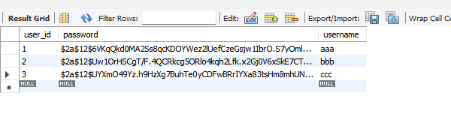

Way 2: Execute the /user/save API from Postman

🡪 this only can be possible if disabling the security for time being by commenting out the code at WebSecurityConfig class

1. Role Table

Insert the entries manually using query

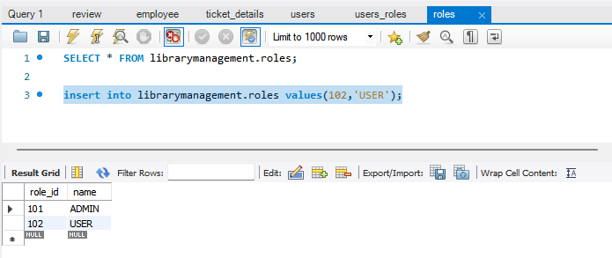

1. Users-roles table

Based on the User Id and Role ID inserted at above tables, accordingly insert the entries into this table for role assignment to the respective user